**ASSIGNMENT-2**

**SETTING REQUIREMENTS**

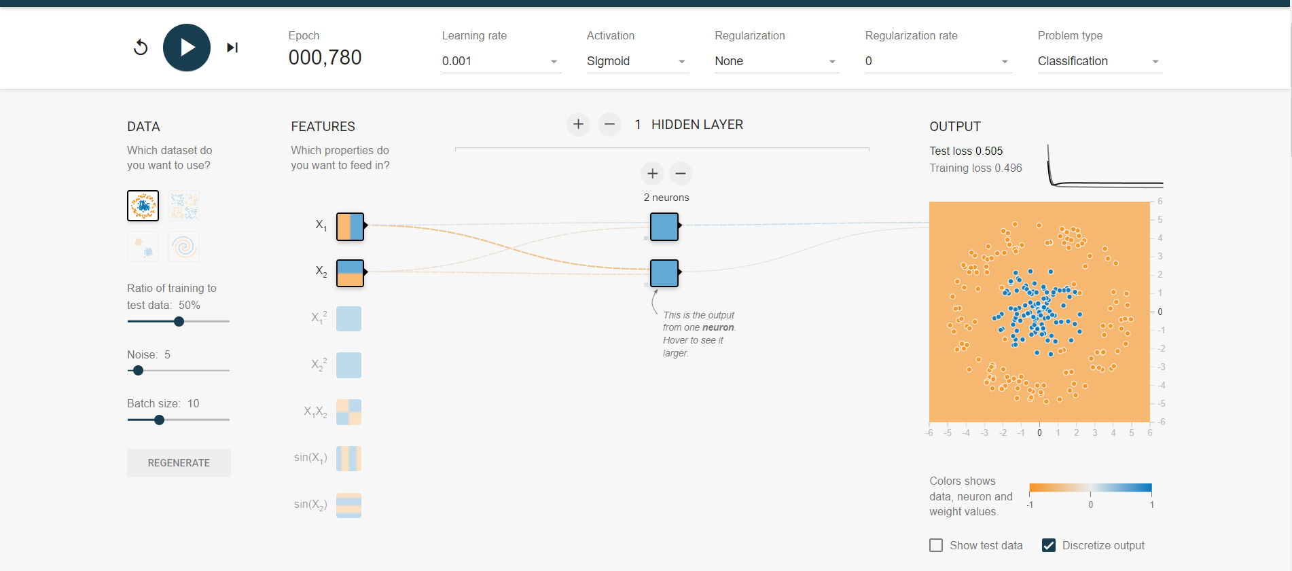

**TASK 1**

**OBSERVATIONS FROM TASK 1**

**USING TANH ACTIVATION**

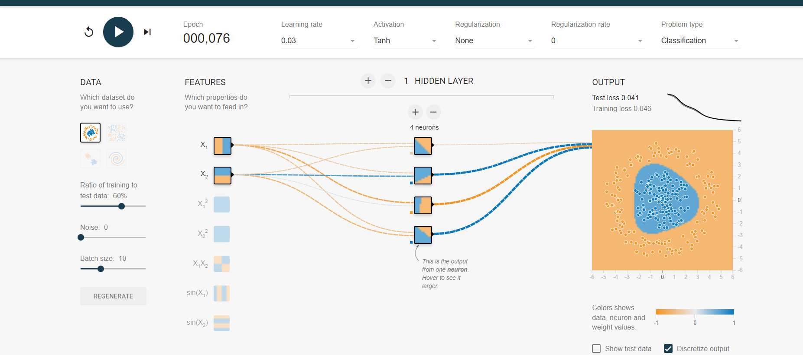

**INCRESING THE LAYERS**

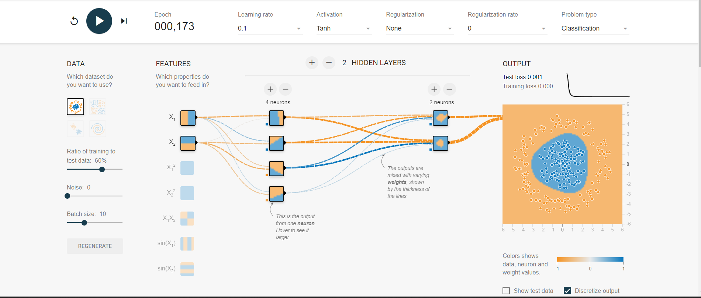

**Adjusting LERNING RATE**

**BEFORE**

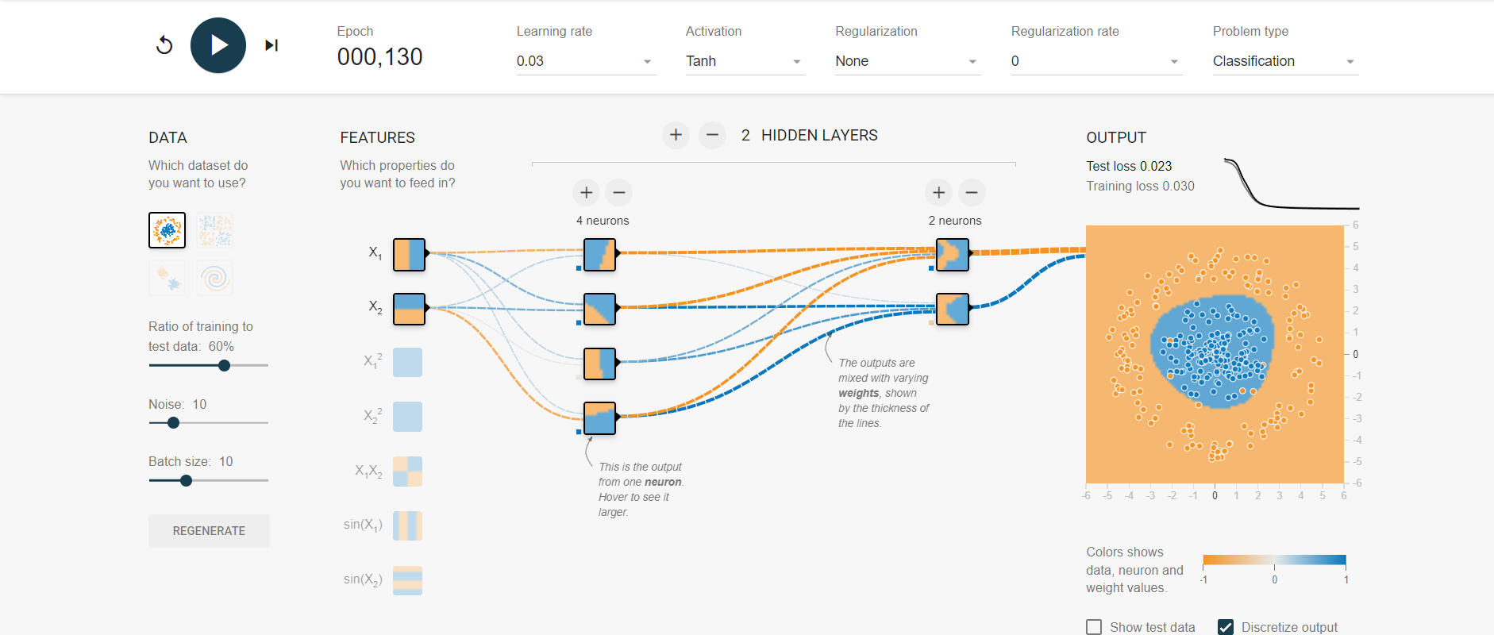

**AFTER**

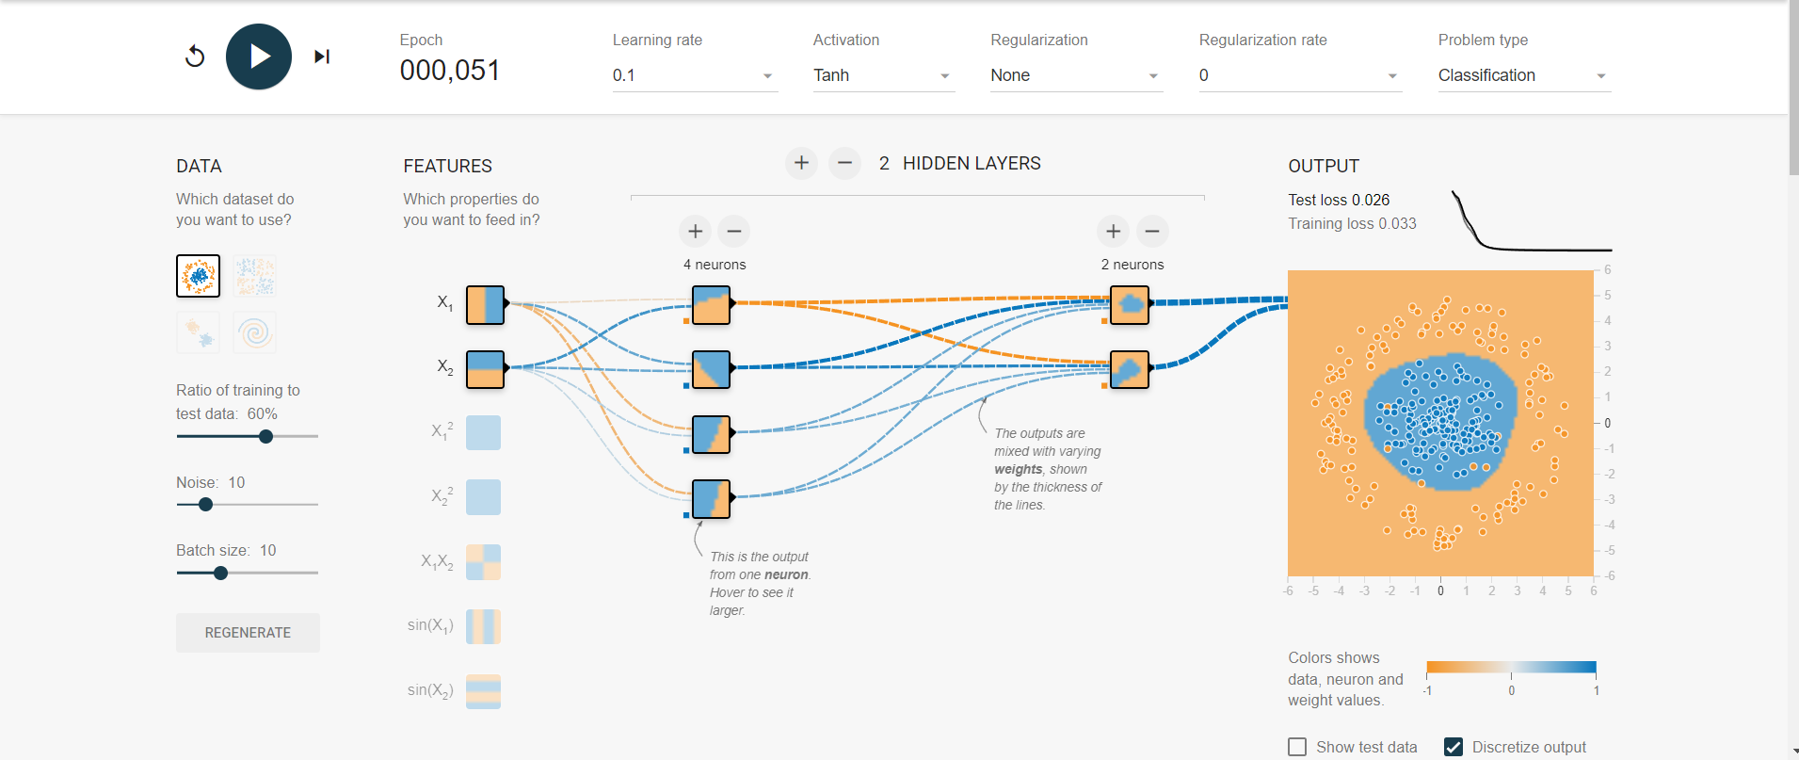

**INCRESING NOISE**

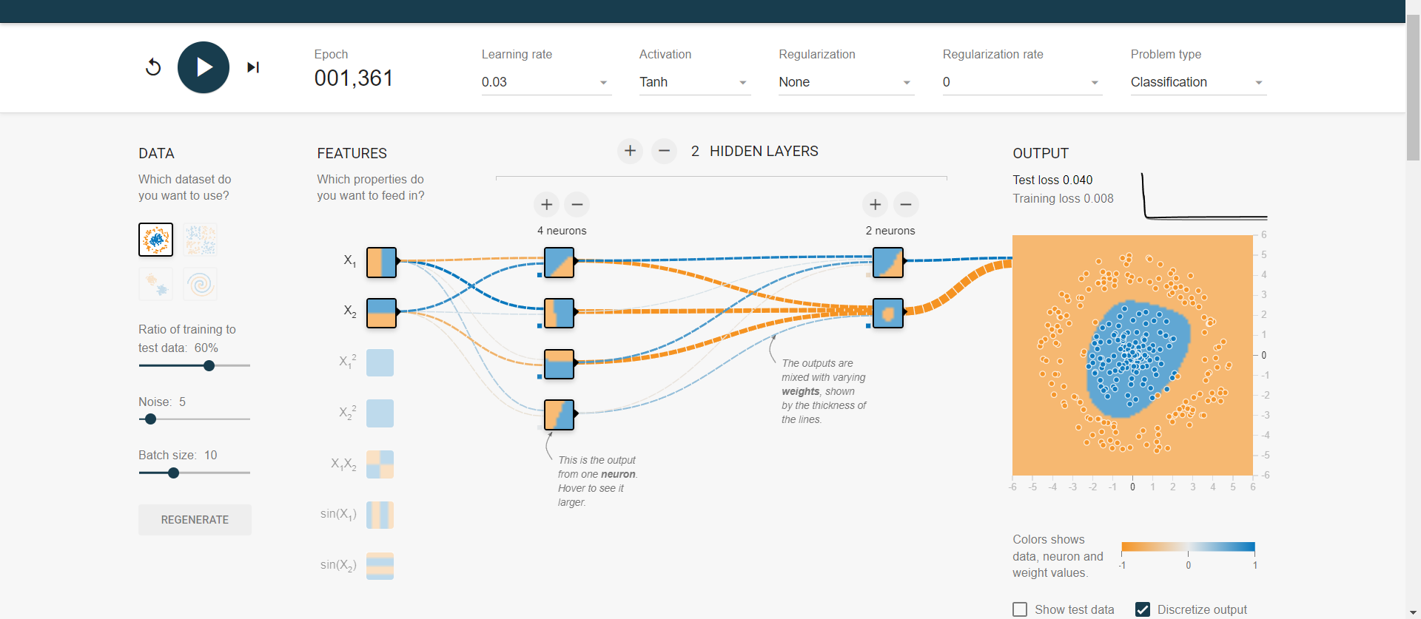

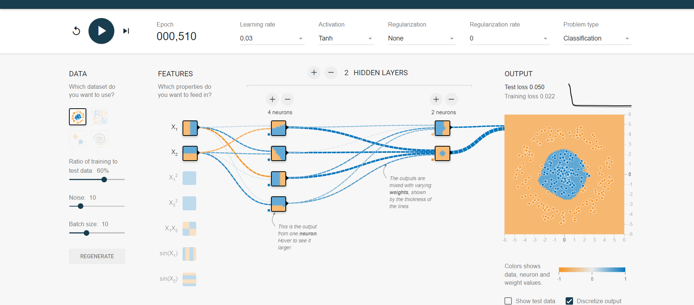

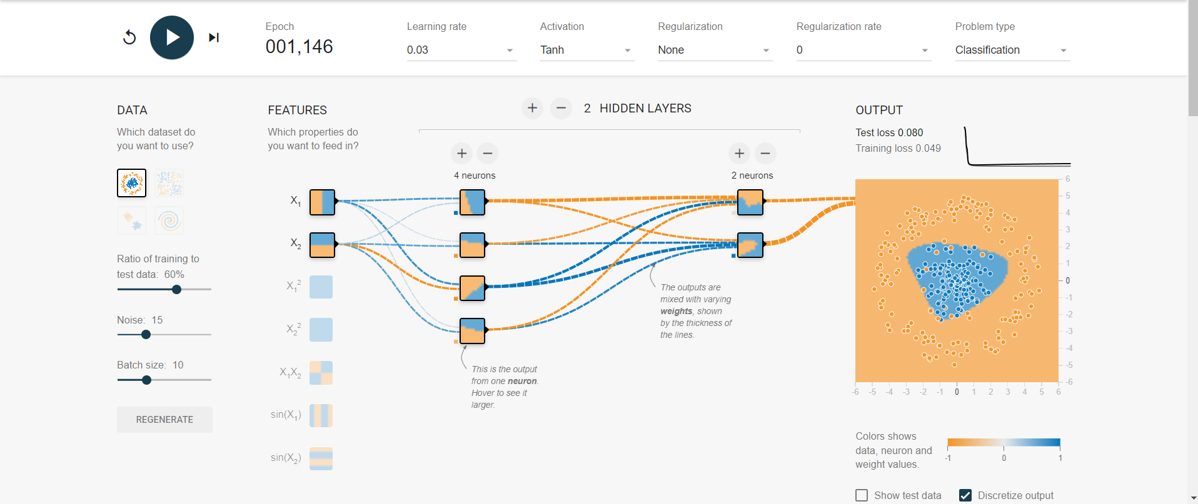

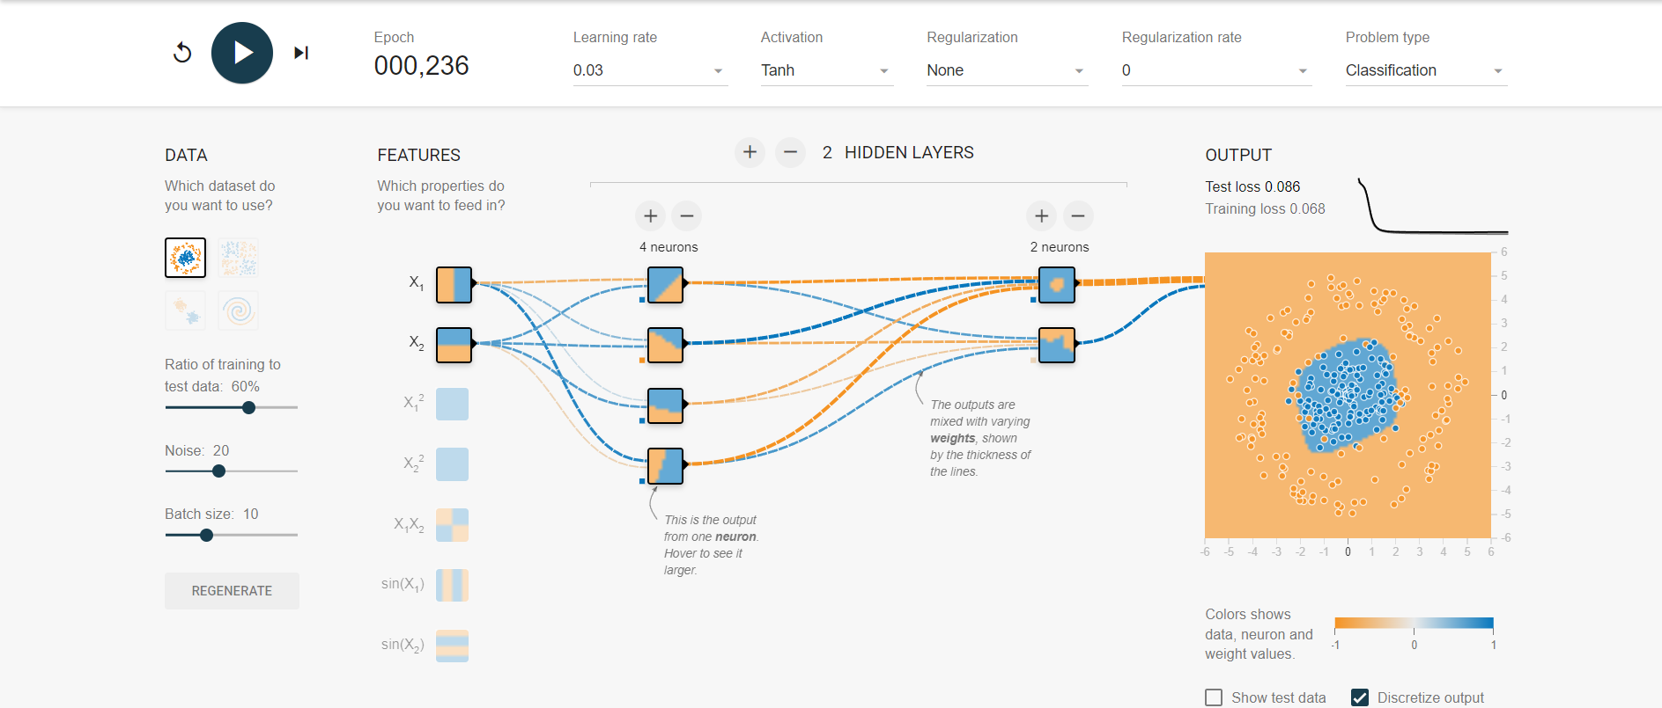

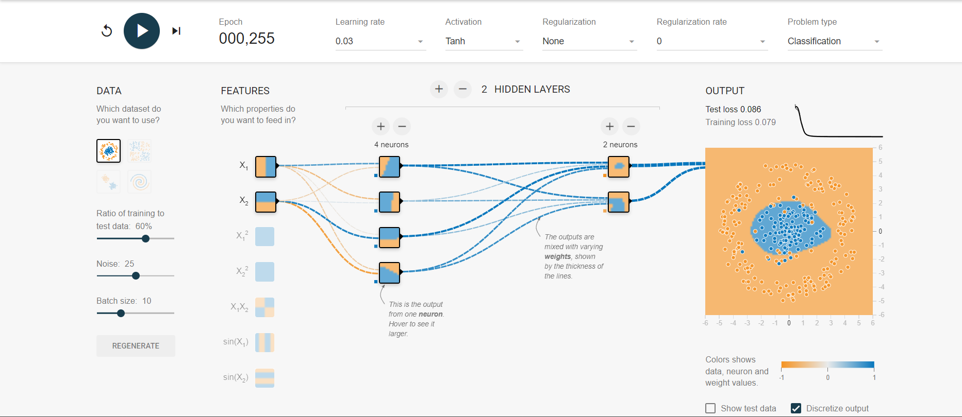

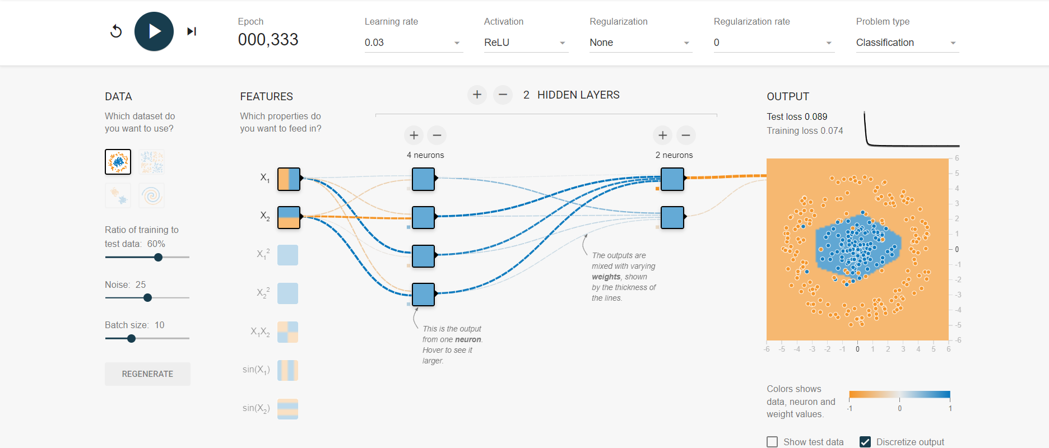

🡺As I observed tanh is more suitable activation than any other activations as tanh gives output in between [-1,1], and also capturers periodic data relu is also very useful for the stable and noise data but as we are using circular data this is not preferable. Sigmoid and linier are not preferable.

🡺 While increasing the noise, changing the learning rate hasn't had a noticeable impact; nevertheless, when the noise rate is zero, changing the learning rate has reduced the test loss.

🡺Adding layers improved my model as there is a huge test loss while using 1 layer but adding more layers the test loss is decreased.

🡺after performing this experiment, I had observed that adjusting learning rate is important as I increased learning rate the test loss is slightly changed and if we give huge learning rate the model will diverge and low learning rate the model will give low coverage.

**TASK 2**

Complexity

Adjusting the layers

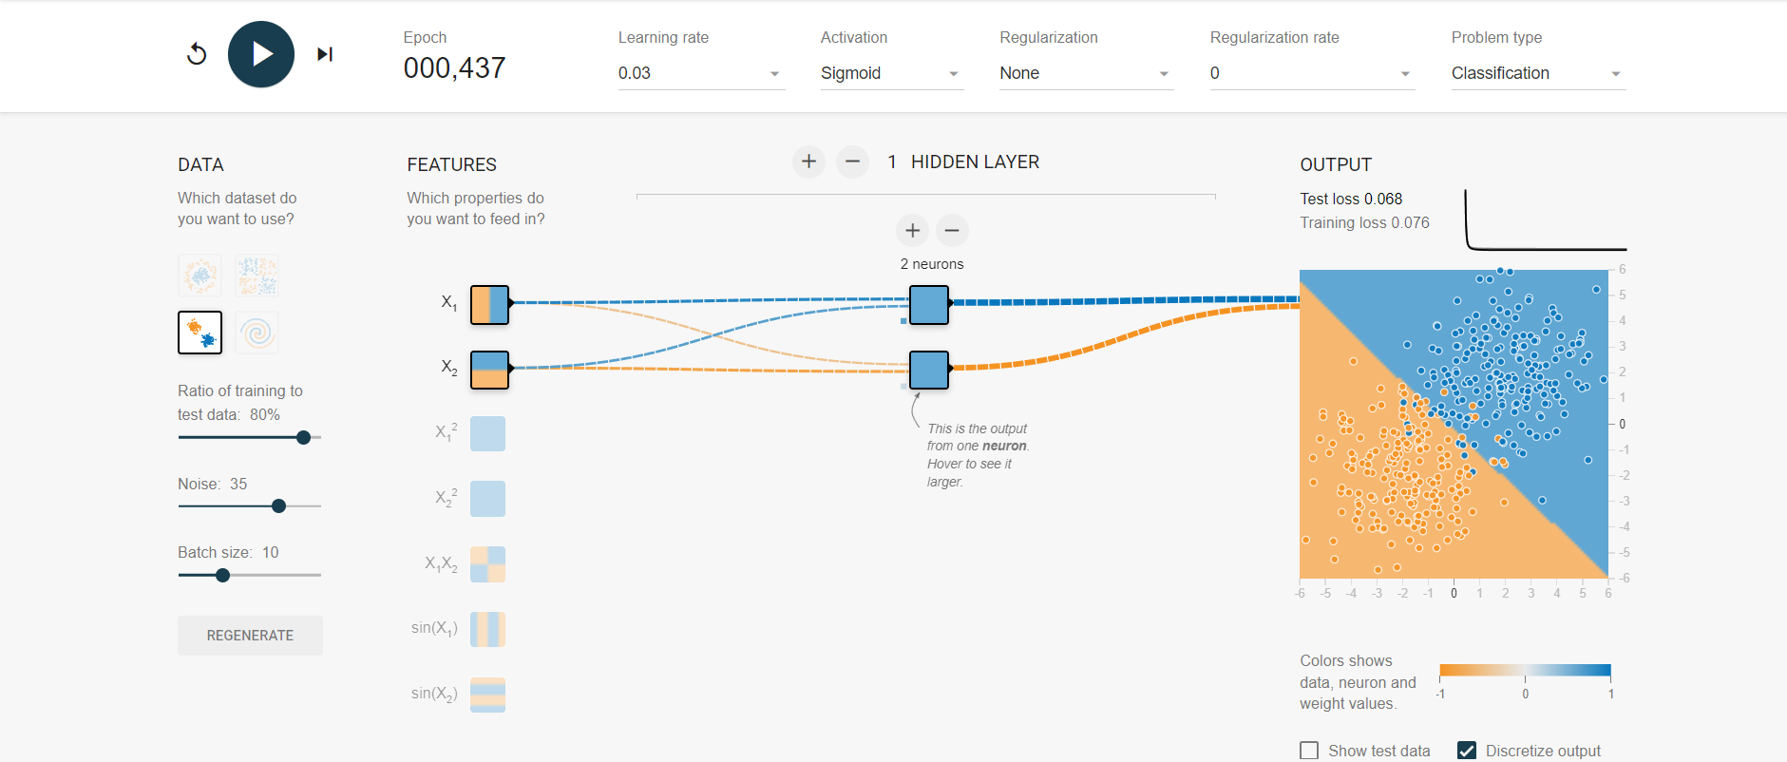

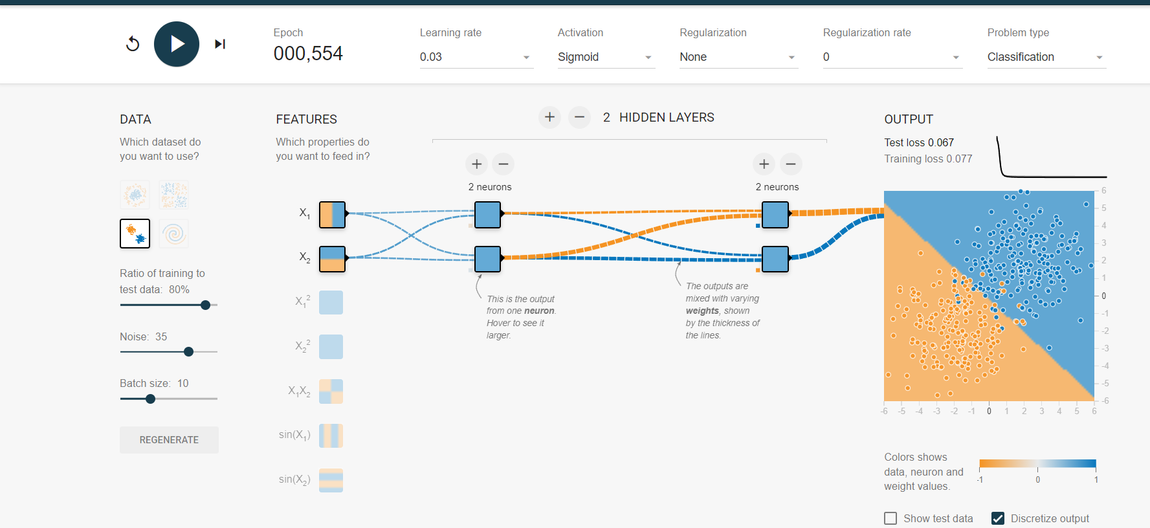

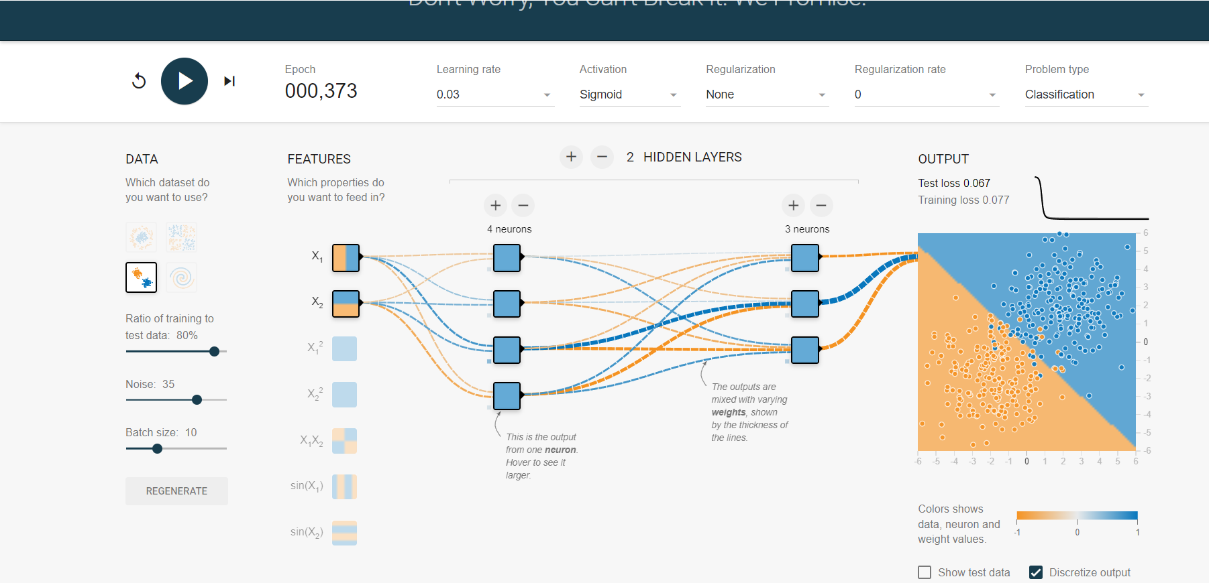

Adjusting learning rate



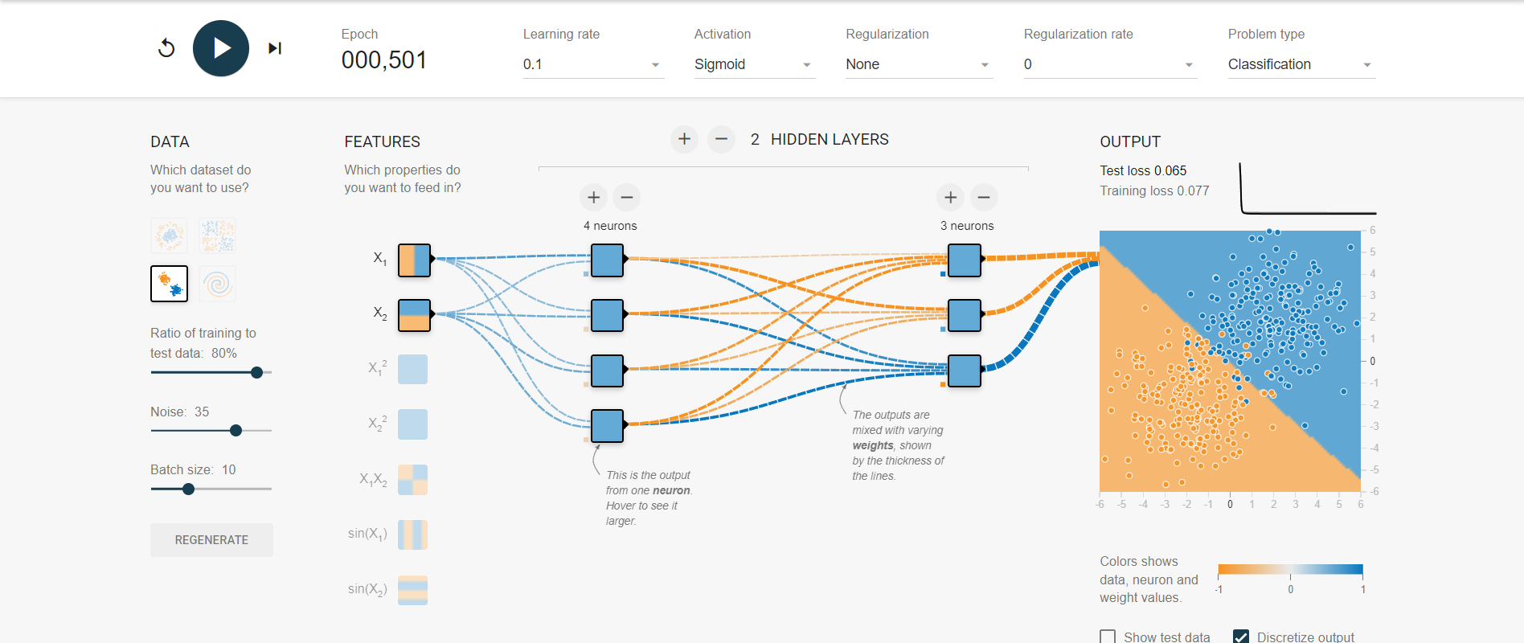

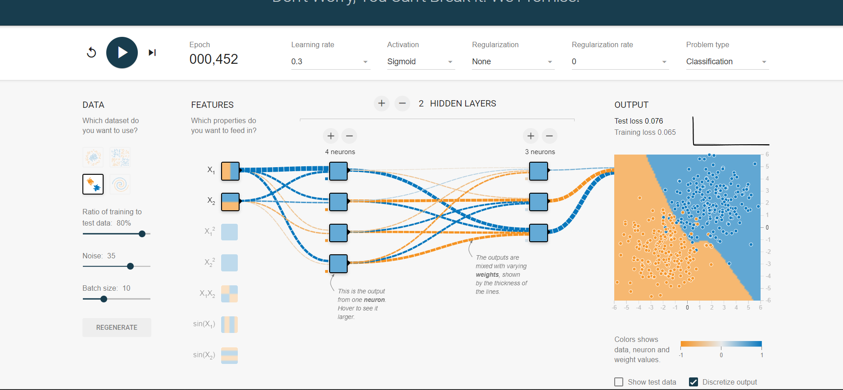

With relu,linear and tanh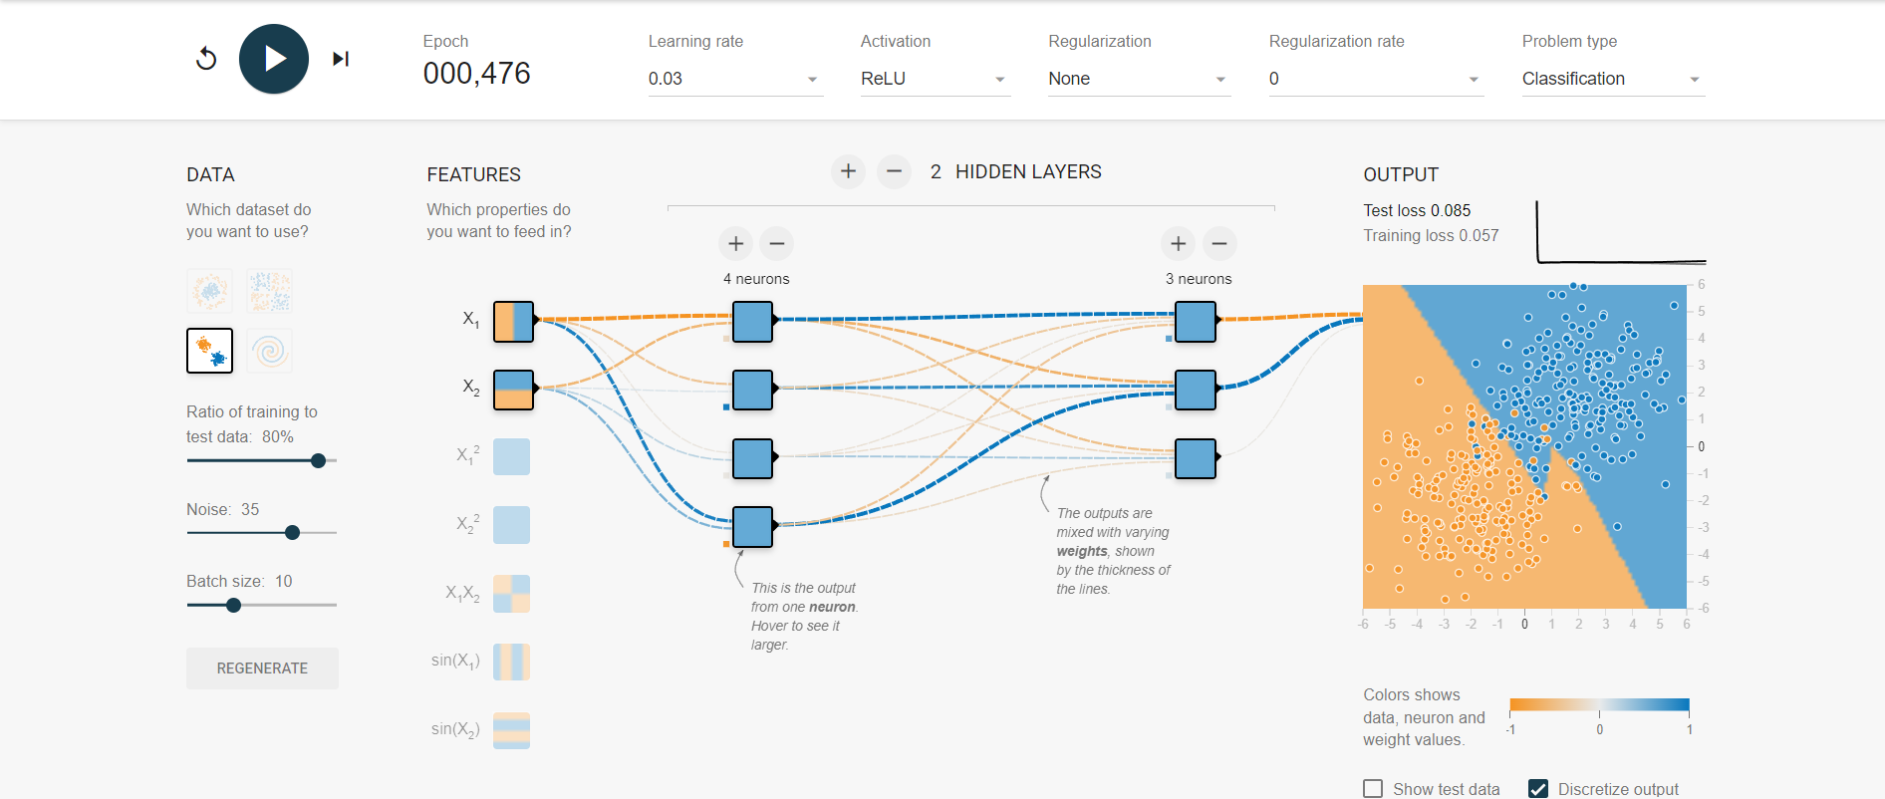

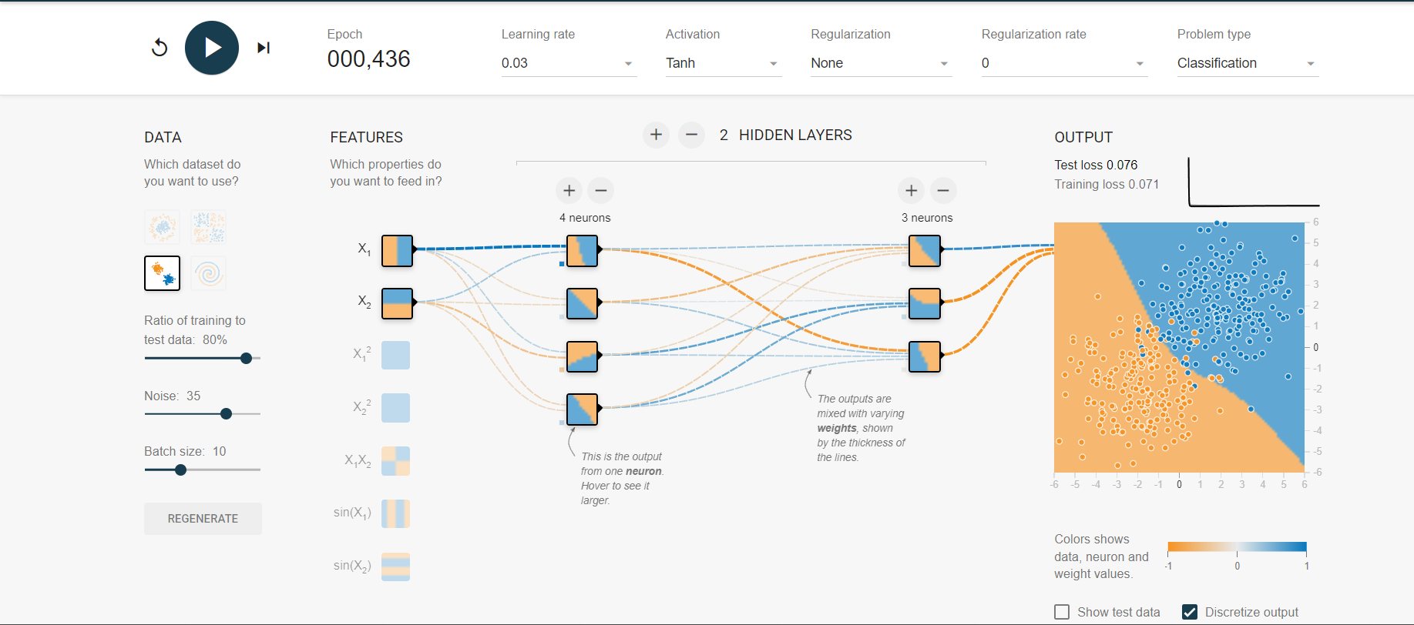

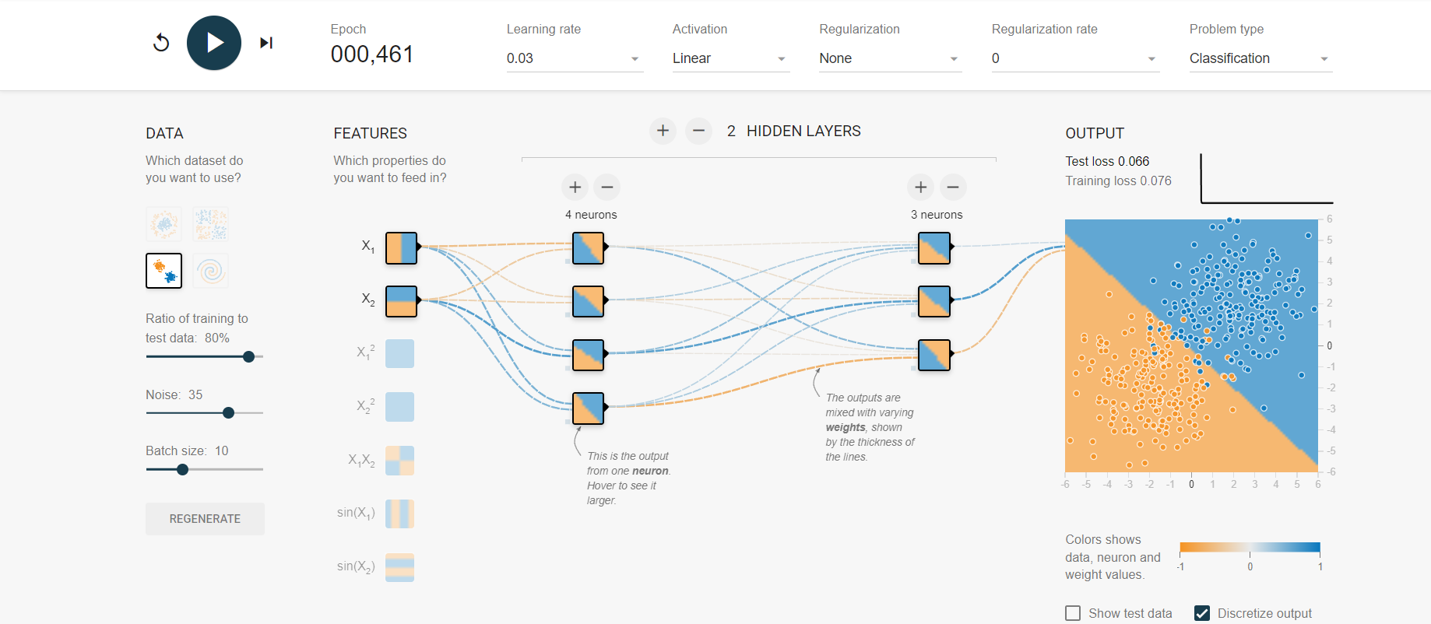

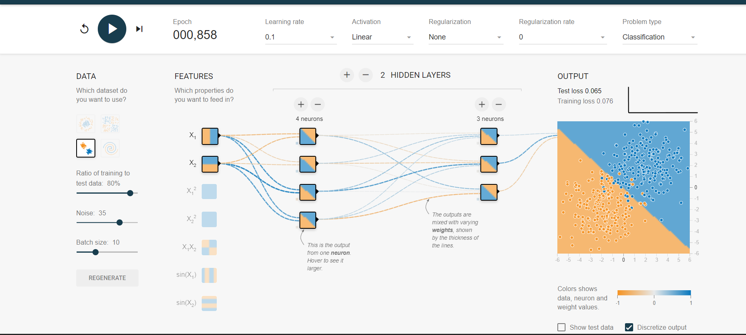

🡺tested while running changed learning rate to 0.1 there is no drastic change in test loss.

🡺there is no major difference while using linear tanh and sigmoid activation functions but there is slight high-test loss while using tanh

🡺 I find that adjusting learning rate and adding more neurons and hidden layers there is no significant impact on the model the test loss is almost same.

**TASK 3**

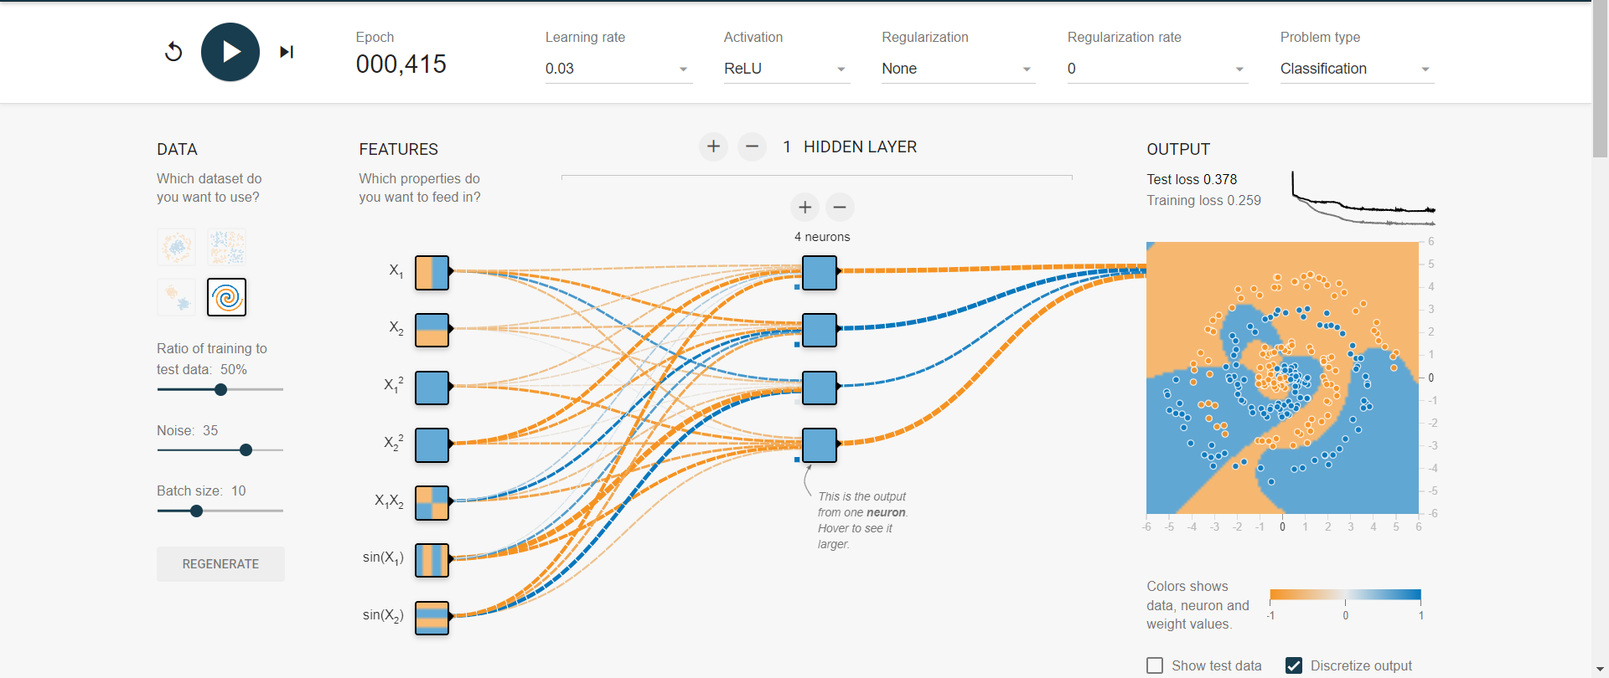

Working with different activation functions

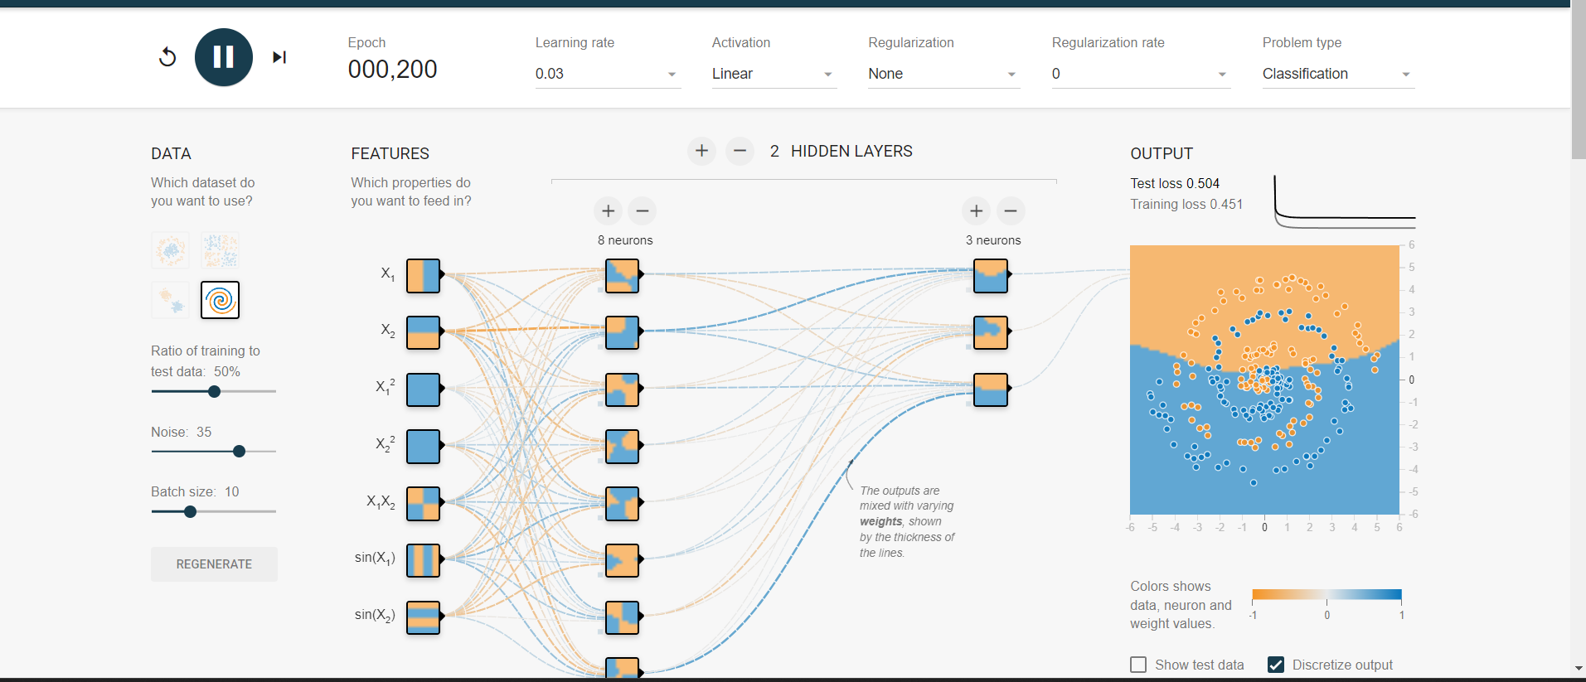

I found out this activation function is not useful as test loss is very high even though adding more layers.

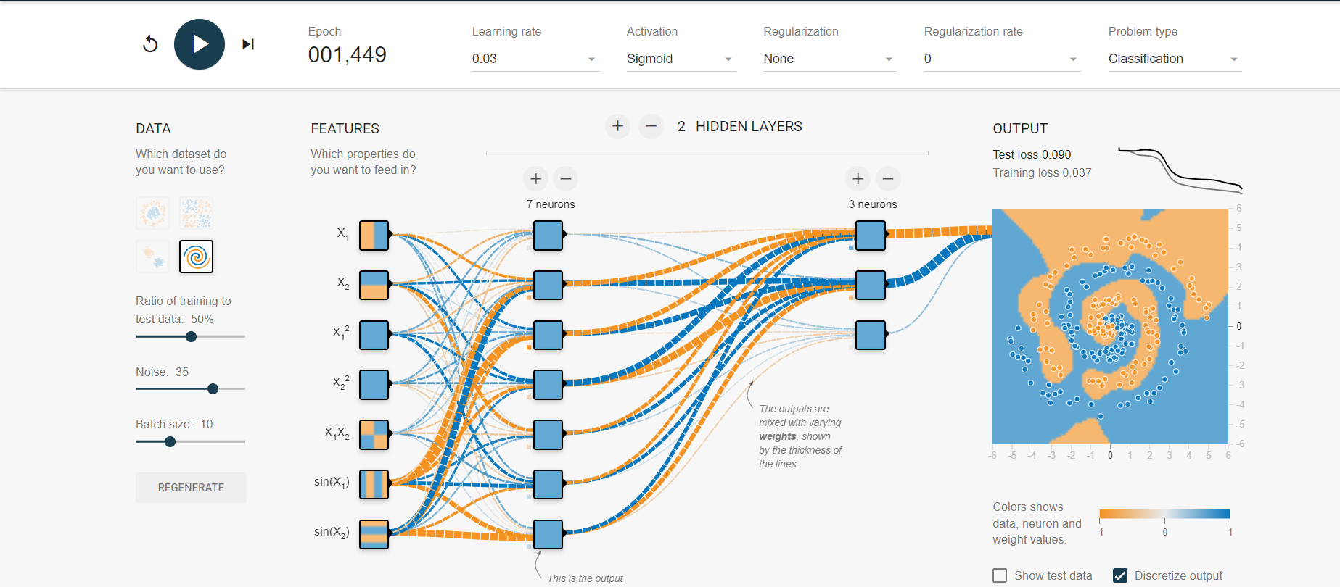

By using sigmoid function we will get the output but it will take more epochs

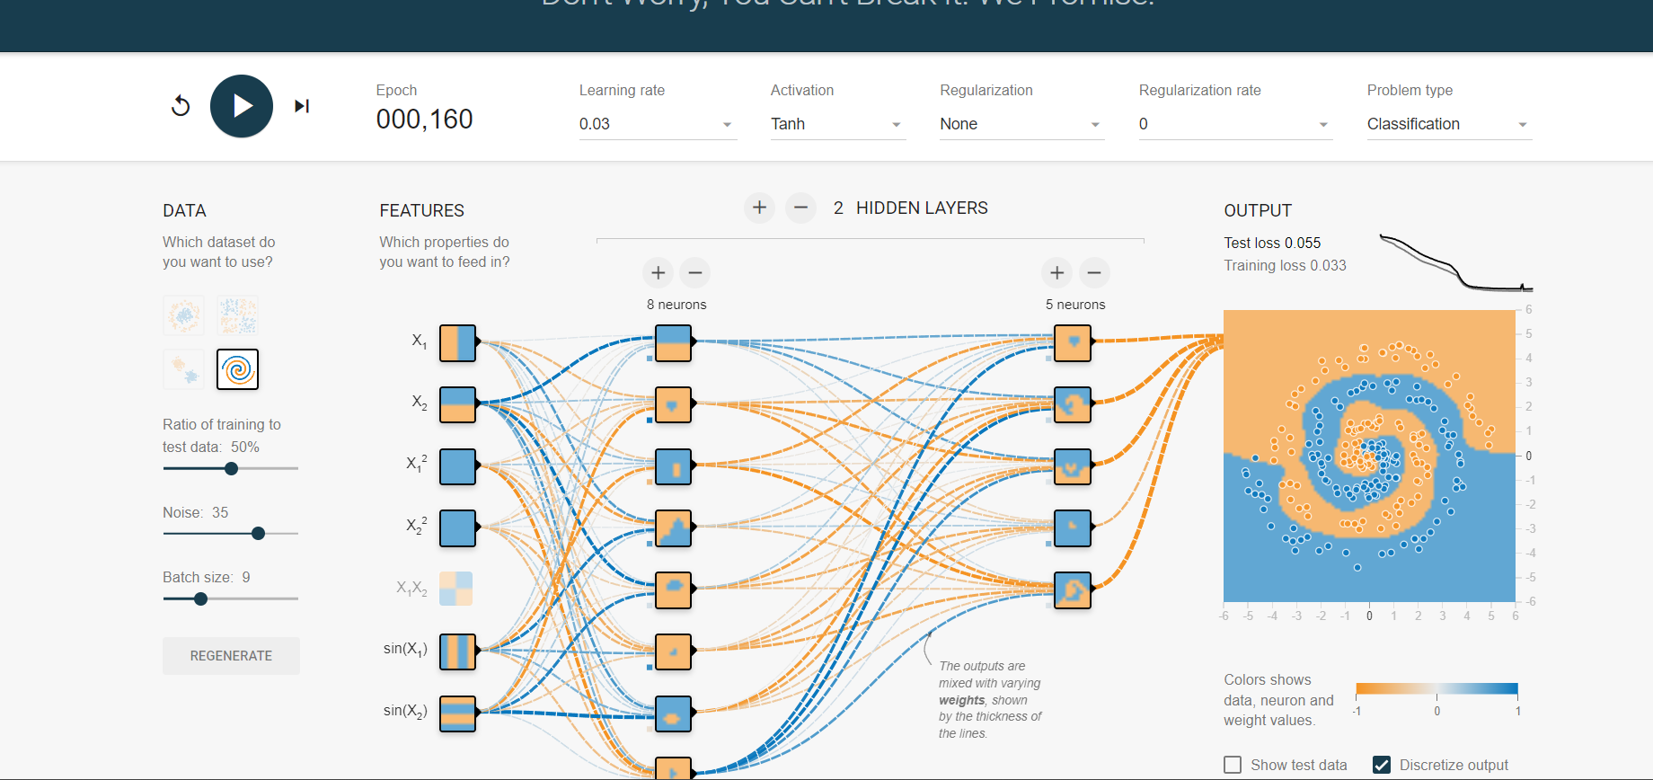

While increasing the layers and decreasing the batch size I got low test loss for the tanh activation

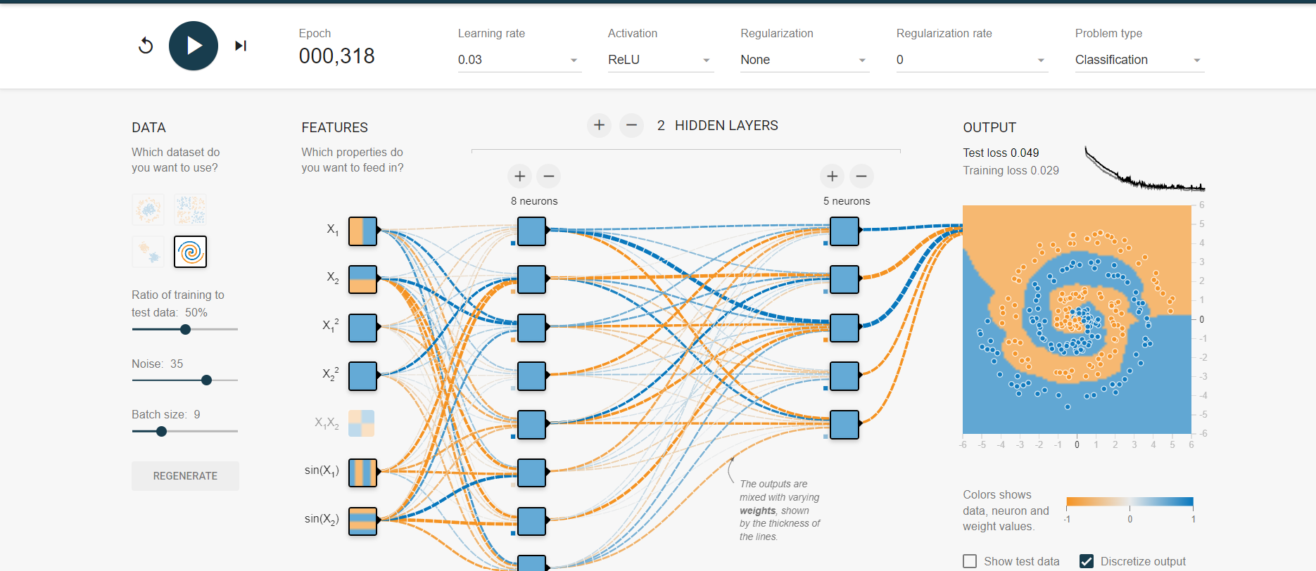

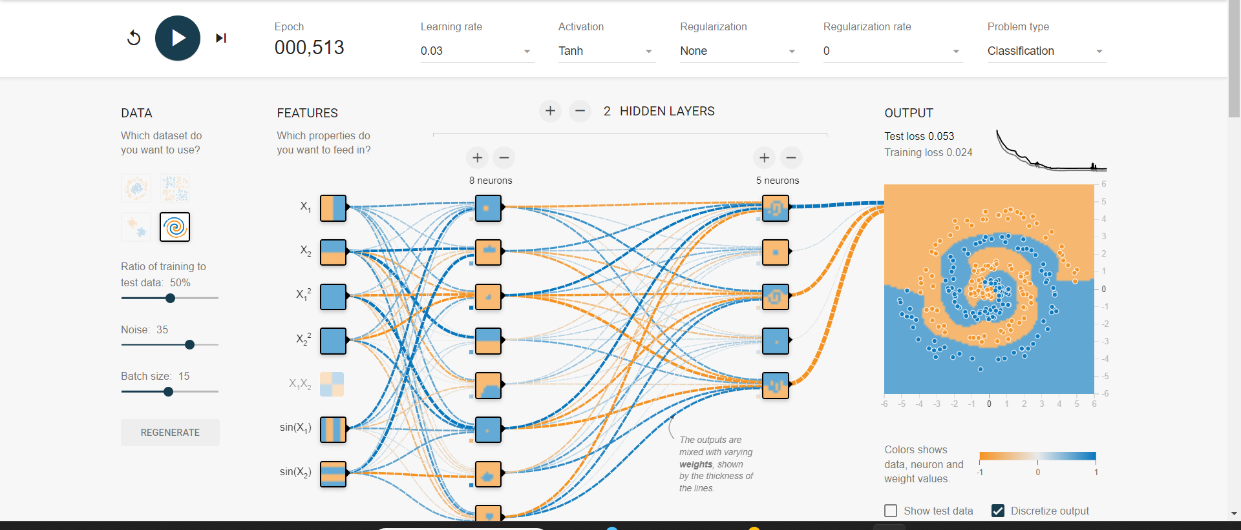

For the batchsize 15 and for the tanh I got stable output and low test loss

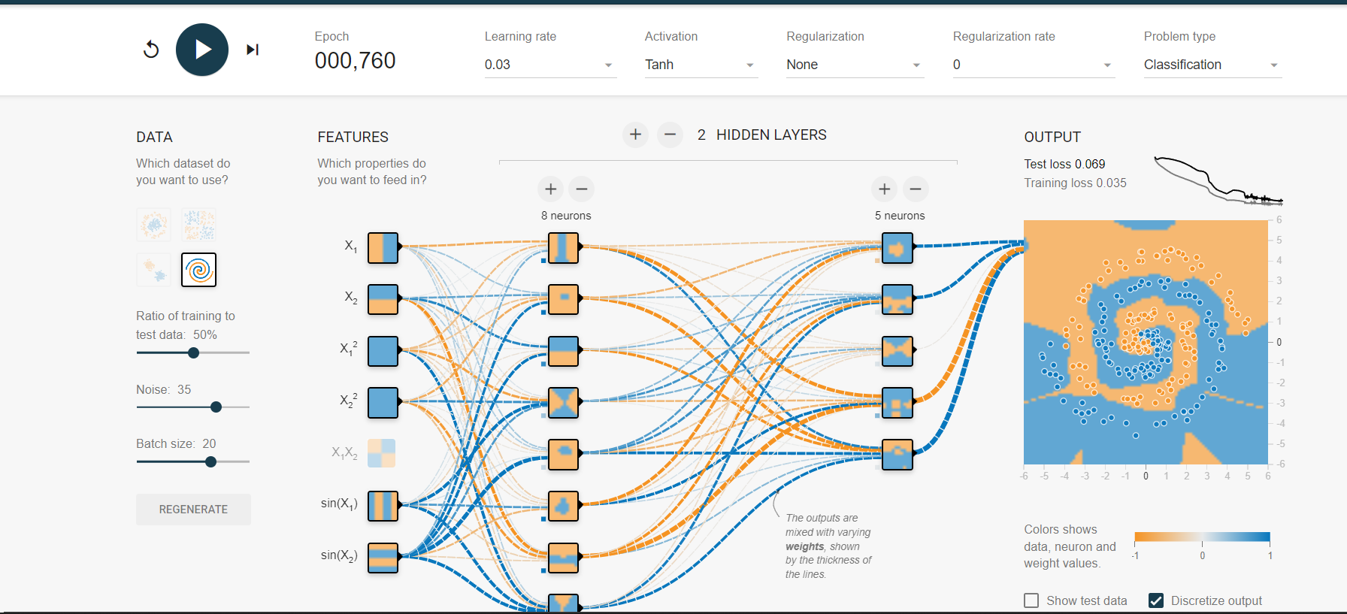

Increasing learning rate

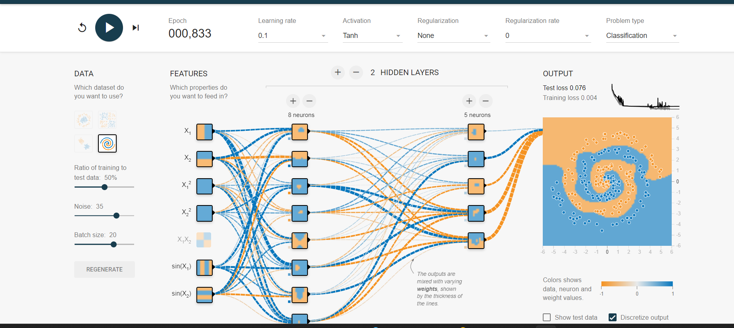

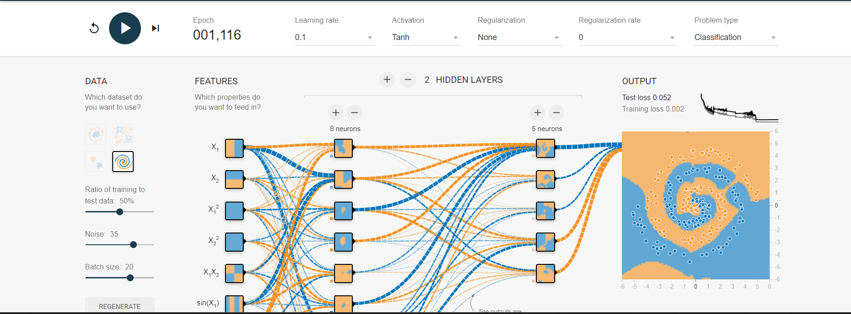

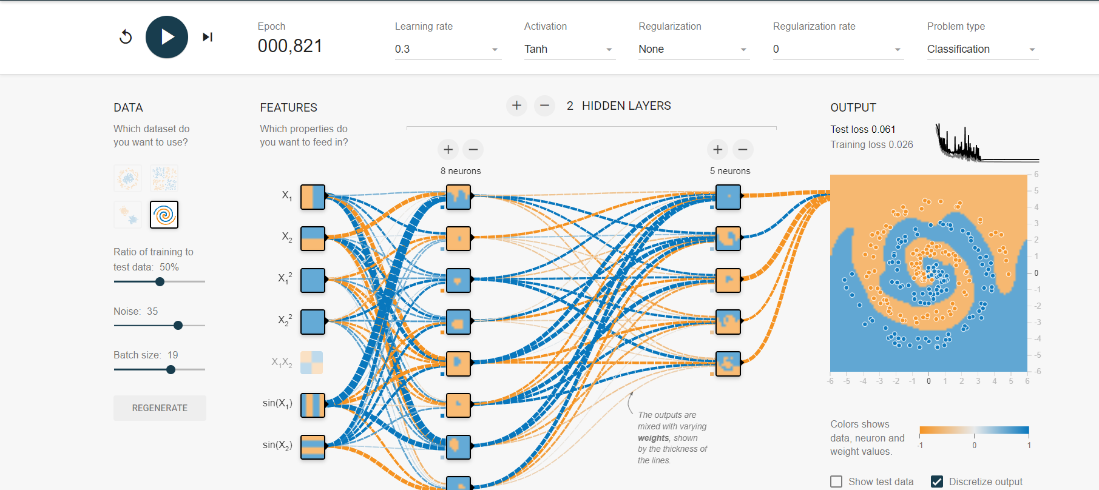

🡺by using a greater number of neurons to the one hidden layer and a smaller number of neurons to another I got a stable output and test loss less than 0.10

🡺I observed that tanh and relu are more significant methods and which gives low test loss.

🡺sigmoid activation function gives low test loss but it takes more epochs.

🡺for the higher learning there is more test loss.

**DELIVERABLES**

**1A**

🡺The training process may be greatly impacted by changing the learning rate. While a learning rate that is too low might cause weak convergence, one that is too high could cause instability . Determining the ideal rate of learning is essential to training that works.

But for the gaussian changing the learning rate might not make a low test loss but for the spiral and circle there are changes.

**2ans**

**🡺**Asi observed from the above experiment for the circular and spiral data set tanh and relu is more suitable than linear and sigmoid functions. Indeed, activation functions are essential for regulating how a neuron reacts to stimuli and whether or not to activate it. Certain activation functions, such as Sigmoid, Tanh, or ReLU, have unique properties. ReLU is frequently chosen in hidden layers as it adds non-linearity. Values are squashed by Tanh to lie between -1 and 1, and by Sigmoid to lie between 0 and 1. The model's capacity for learning and generalization is influenced by the selection of activation function.

**3ans**

**🡺**The model's ability to recognize intricate patterns is improved by adding layers. If there are too many layers, the model may become overfit, which prevents it from generalizing to new data even though it has learned the training set. The problem's intricacy and the volume of accessible data determine how additional layers will affect things.

**4ans**

**🡺**At high learning rates, the optimization process might become unstable. The model might oscillate between different weight values, leading to slow convergence or divergence. This instability can result in the model failing to learn effectively. It's crucial to find an optimal learning rate that allows for fast convergence without sacrificing stability. As we know that the task 3 the learning rate when it was at 0.03 the test loss is not stable and I increased learning rate I got astable output with less test loss.

